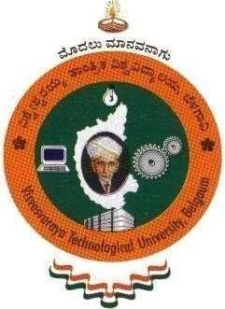

**“SOCIAL CONNECT AND RESPONSIBILITIES”**

**Course Code: BSCK307**

*A Report submitted to*

***Visvesvaraya Technological University*** *in partial fulfillment of the requirements for the award of degree of*

# Bachelor of Engineering in

**Computer Science and Engineering**

*Submitted by* **NAME: CHINMAY B H USN: 1KS23CS060**

**SEMESTER: III**

**SECTION: A**

**Department of Computer Science and Engineering**

# K S INSTITUTE OF TECHNOLOGY

No.14 , Raghuvanahalli , Kanakapura Main Road , Bengaluru - 560019

# 2024–2025



**K S INSTITUTE OF TECHNOLOGY**

No. 14 , Raghuvanahalli, Kanakapura Main Road, Bangalore – 560109

## DEPARTMENT OF COMPUTER SCIENCE AND ENGINEERING

**CERTIFICATE**

This is to certify that the “**SOCIAL CONNECT AND RESPONSIBILITIES (Course Code: BSCK307) activity”** is a Bonafide work carried out by

Name: JEEVAN M

USN: 1KS23CS060

in partial fulfilment for the award of **Bachelor of Engineering** in **Computer Science and Engineering** of the **Visvesvaraya Technological University**, Belgaum during the year 2024–2025. It is certified that all corrections / suggestions indicated for internal assessment have been incorporated in the report deposited in the departmental library.

The report has been approved as it satisfies the academic requirement in respect of course prescribed for the Degree.

|  |  |
| --- | --- |
| **Marks Obtained:** |  |
| **Total Marks:** | **100** |

## Internal assessment marks awarded:

|  |  |  |  |
| --- | --- | --- | --- |
| **Signature of Course In-charge** | **Signature of NSS Officer** | **Signature of HOD, CSE** | **Signature of Principal** |

I



Only two pages were converted.

Please **Sign Up** to convert the full document.

[**www.freepdfconvert.com/membership**](https://www.freepdfconvert.com/membership)